**Part-II**

**1.Campus and Infrastructure**

a. Available Land area in square meters

66,975.4 Sq.Mts.

b. Whether the available land is on

* Ownership basis

**c. Multi–storey building built-up area in square meters on each flour**

|  |  |  |
| --- | --- | --- |
| S. No. | Floor | Built-up area in Square Meters |
| 1. | Ground Flour | 1337.7 |
| 2. | First Flour | 1337.7 |
| 3. | Second Flour | 1337.7 |
| 4. | Third Flour | 1337.7 |
|  | Total Area | 5350.8 |

**d. Fire safety equipment has been installed yes**

The same are installed as per Building Bye Laws No

e. Facilities available for different abled persons No

f. Hostel facilities are available Yes

i. Separate facilities are available for female students Yes

ii. Number of male and female students for whom facilities are available

|  |
| --- |
| 15 |

Male Students

|  |
| --- |
| 15 |

Female Students

**g.(i) Available infrastructure**

|  |  |  |  |
| --- | --- | --- | --- |
| **S. No.** | **Infrastructure** | **Whether available: Yes/No** | **Size in Sq. ft.** |
| a. | Classroom  1.Classroom 1  2.Classroom 2  3.Classroom 3  4.Classroom 4 | Yes  Yes  Yes  Yes | 1210.5  727.5  730.41  1102 |
| b. | Multipurpose Hall | Yes | 3027.05 sq.ft. |
| c. | Library-cum-Reading Room | Yes | 1848 |
| d. | ICT Resource Centre | Yes | 1374.16 |
| e. | Curriculum Laboratory  Psychology Lab  Technology Lab  Science Lab | Yes | 1210.6  727.5  1008.14 |
| f. | Art &Resource Centre | Yes | 730.41 |
| g. | Health &Physical Education Resource Centre | Yes | 730.4 |
| h. | Multipurpose Playfiled | Yes | 109795.48 |
| G.(ii) Following facilities are available in the Institution | | | |
| a. | Principal’s Office | Yes | |
| b. | Staff Rooms | Yes | |
| c. | Administrative Office | Yes | |
| d. | Visitors Room | Yes | |
| e. | Separate Common Room for male & female students | Yes | |
| f. | Seminar Room | Yes | |
| g. | Canteen | Yes | |
| h. | Separate Toilet facility for male & female students | Yes | |
| i. | Separate Toilet facility for Staff | Yes | |
| j. | Separate Toilet facility for differently abled persons | No | |
| k. | Parking Space | Yes | |
| l. | Open space for Additional Accommodation | Yes | |
| m. | Store Room | Yes | |
| n. | Medical facility | Yes | |
| o. |  |  | |
| p. |  |  | |

**2. Teaching and Non-teaching staff**

No. of staff members in position at the time of commencement of the Current Session:

|  |
| --- |
| 01 |

1. Principal
2. Academic Staff :

|  |
| --- |
| 0 |

* Professor

|  |
| --- |
| 0 |

* Associate Professor

|  |
| --- |
| 15 |

* Assistant Professor

|  |
| --- |
| 0 |

* Any other

|  |
| --- |
| 1+15 |

* Total Academic Staff

|  |
| --- |
| 05 |

1. **Total Administrative, Technical and Professional Staff**

**d. No. of Vacant position as on the date of last Revision of website**

|  |  |  |  |  |
| --- | --- | --- | --- | --- |
| S. No. | Academic Positions | No. of Vacant Positions | Other Staff | No. of Vacant Position |
| i. | Principal | NIL | Administrative Staff | NIL |
| Ii. | Professor | -------- | Technical Staff | NIL |
| Iii. | Associate Professor | -------- | Professional Staff | NIL |
| iv. | Assistant Professor | NIL |  |  |

**e. Number of Academic and other Staff recruited during the Current Session**

|  |
| --- |
| 01 |

**Academic**

|  |
| --- |
| 00 |

**Other**

**f. Number of Academic and other Staff who left the institution during the Current**

|  |
| --- |
| 0 |

**Session (2019-20)**

**Academic**

|  |
| --- |
| 0 |

**Other**

**3.Students on the Rolls of the Institutions**

|  |
| --- |
| 05.04.2021 |

**a) Date of commencement of the current academic session**

|  |
| --- |
| 30.04.2021 |

**b) Last date fixed by the affiliating body for admission**

|  |
| --- |
| 30.04.2021 |

**c) Date of last admission made in the institution**

**d) Mode of selection of students**

* **Selected by Affiliating Body**
* **Selected by State Government √**
* **Selected by Institution √**

|  |
| --- |
| 96 |

**e) Institution /State Govt. selected through merit list**

**f) No. of students in enrolled in the current academic session I Year**

**g) Category – wise distribution of students**

**I YEAR STUDENTS**

|  |  |  |  |  |  |  |  |
| --- | --- | --- | --- | --- | --- | --- | --- |
| **Programme** | **No. of Male Students** | **NO. of Female Students** | **No of students enrolled in SC Category** | **No. Students enrolled in ST Category** | **No. Students enrolled in OBC Category** | **No. Students enrolled in Unreserved Category** | **Total Students in Programme** |
| **B.Ed.** | **21** | **75** | **10** | **02** | **53** | **31** | **96** |

**b) I YEAR STUDENTS**

|  |  |  |
| --- | --- | --- |
| **Programme Name** | **Pedagogy Subjects** | **Number of Students Enrolled** |
| B.Ed. | English | 25 |
| Hindi /Regional Language | 21 |
| Social Science | 42 |
| Mathematics | 18 |
| Physical Science | 33 |
| Life Science | 15 |
| Any other type | 38 |

|  |
| --- |
| 96 |

**f) No. of students in enrolled in the current academic session II Year**

**g) Category – wise distribution of students**

**II Year STUDENTS**

|  |  |  |  |  |  |  |  |
| --- | --- | --- | --- | --- | --- | --- | --- |
| **Programme** | **No. of Male Students** | **NO. of Female Students** | **No of students enrolled in SC Category** | **No. Students enrolled in ST Category** | **No. Students enrolled in OBC Category** | **No. Students enrolled in Unreserved Category** | **Total Students in Programme** |
| **B.Ed.** | **12** | **84** | **09** | **03** | **50** | **34** | **96** |

**b) II Year STUDENTS**

|  |  |  |
| --- | --- | --- |
| **Programme Name** | **Pedagogy Subjects** | **Number of Students Enrolled** |
| B.Ed. | English | 25 |
| Hindi /Regional Language | 31 |
| Social Science | 52 |
| Mathematics | 28 |
| Physical Science | 37 |
| Life Science | 09 |
| Any other type | 10 |

**4. Financial Status**

**a. Endowment Fund maintained by the TEI**

**Amount** 7,00,000

**Bank** Canara Bank Khade Bazar Belgaum Main

FDR Number KQ 807646

**b.Reserve Fund maintained by the TEI**

**Amount** 50,00,000

**Bank** Canara Bank Khade Bazar Belgaum Main

FDR Number KQ 807645

**c. Annual fees charged from students of different Programmes and Annual fees**

**Fixed by the State Govt. for different Programmes**

|  |  |  |  |
| --- | --- | --- | --- |
| **S No.** | **Programme** | **Total Annual Fees charged by the Institution (Current Session)** | **Fees fixed by the State Government**  **(Current Session)** |
| 01 | B.Ed. | 18,000/- (Govt. Students) | 18,000/-(Govt. Students) |
| 02 | B.Ed. | 40,000/-(Management Students) | 40,000/- (Management Students) |

**d. Mention if Fee concession or scholarships are given to students Yes**

|  |  |  |  |  |
| --- | --- | --- | --- | --- |
| **S No.** | **Details of Students** | **No. of Students** | **Fee concession/ scholarship per student(Average)** | **Total Fees** |
| 01 | S. C. Students | 12 | 11,965/- | 1,43,580/- |
| 02 | S. T. Students | 06 | 12,965/- | 77,790/- |
| 03 | OBC Students | 34 | 4939/- | 1,67,920 |
| Grand Total = 3,89,290/- | | | | |

**e. Income during the previous academic session(2019-20)**

|  |  |  |
| --- | --- | --- |
| **S.No.** | **Head/Source of Income** | **Income in INR**  **(Write NA for not applicable)** |
| 01 | Income from fees | 50,71,540/- |
| 02 | Grant received from State govt. If any | N.A. |
| 03 | Income from other sources:  donation etc. | N.A. |
| Total income | | 50,71,540/- |

**f. Expenditure during the Previous Academic Session**

|  |  |  |
| --- | --- | --- |
| **S. No.** | **Head of Expenditure** | **Expenditure in INR**  **(Write NA for not applicable)** |
| **A** | **Capital Expenditure** |  |
| 1. | Expenditure incurred on augmentation of infrastructure | 1,38,911/- |
| 2. | Expenditure incurred on augmentation of Instructional Resources | 4,91,948/- |
| **B.** | **Recurring Expenditure** |  |
| 3. | Staff Salary | 20,91,428/- |
| 4. | Interest Payment on loans | N.A. |
| 5. | Loan Repayment | N.A. |
| 6. | Miscellaneous expenditure | 10,288/- |
| **C.** | **Transfer to Capital Account** |  |
| 7. | Transfer to Government Body | N.A. |
|  | Total Expenditure | **27,32,575/-** |

**G.Balance Sheet of the previous Academic Session has been displayed**

Yes Displayed

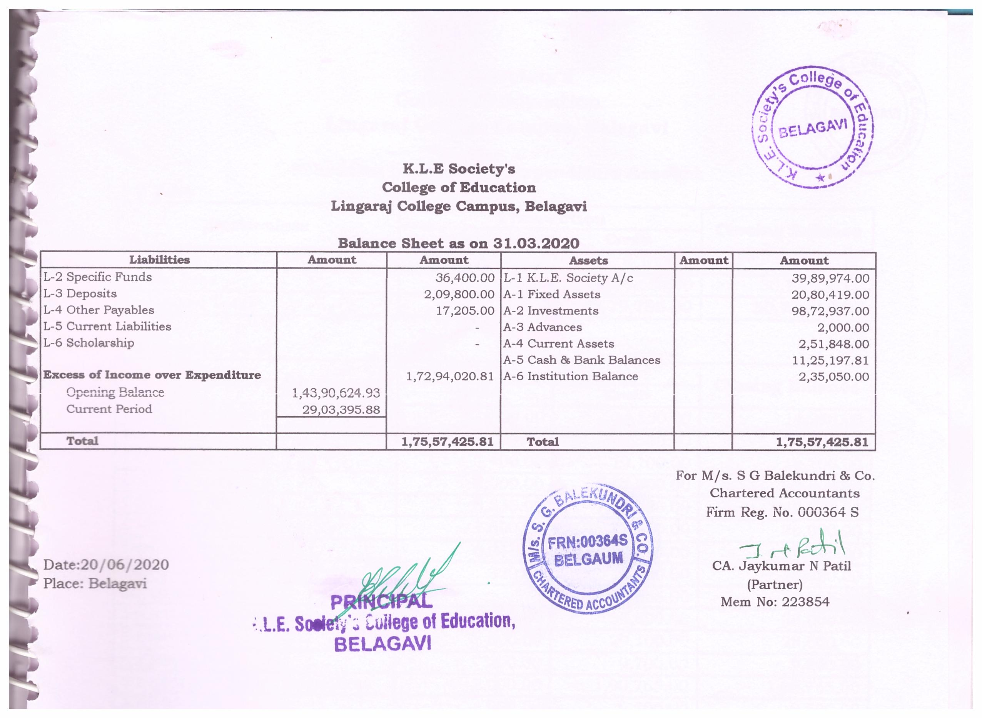

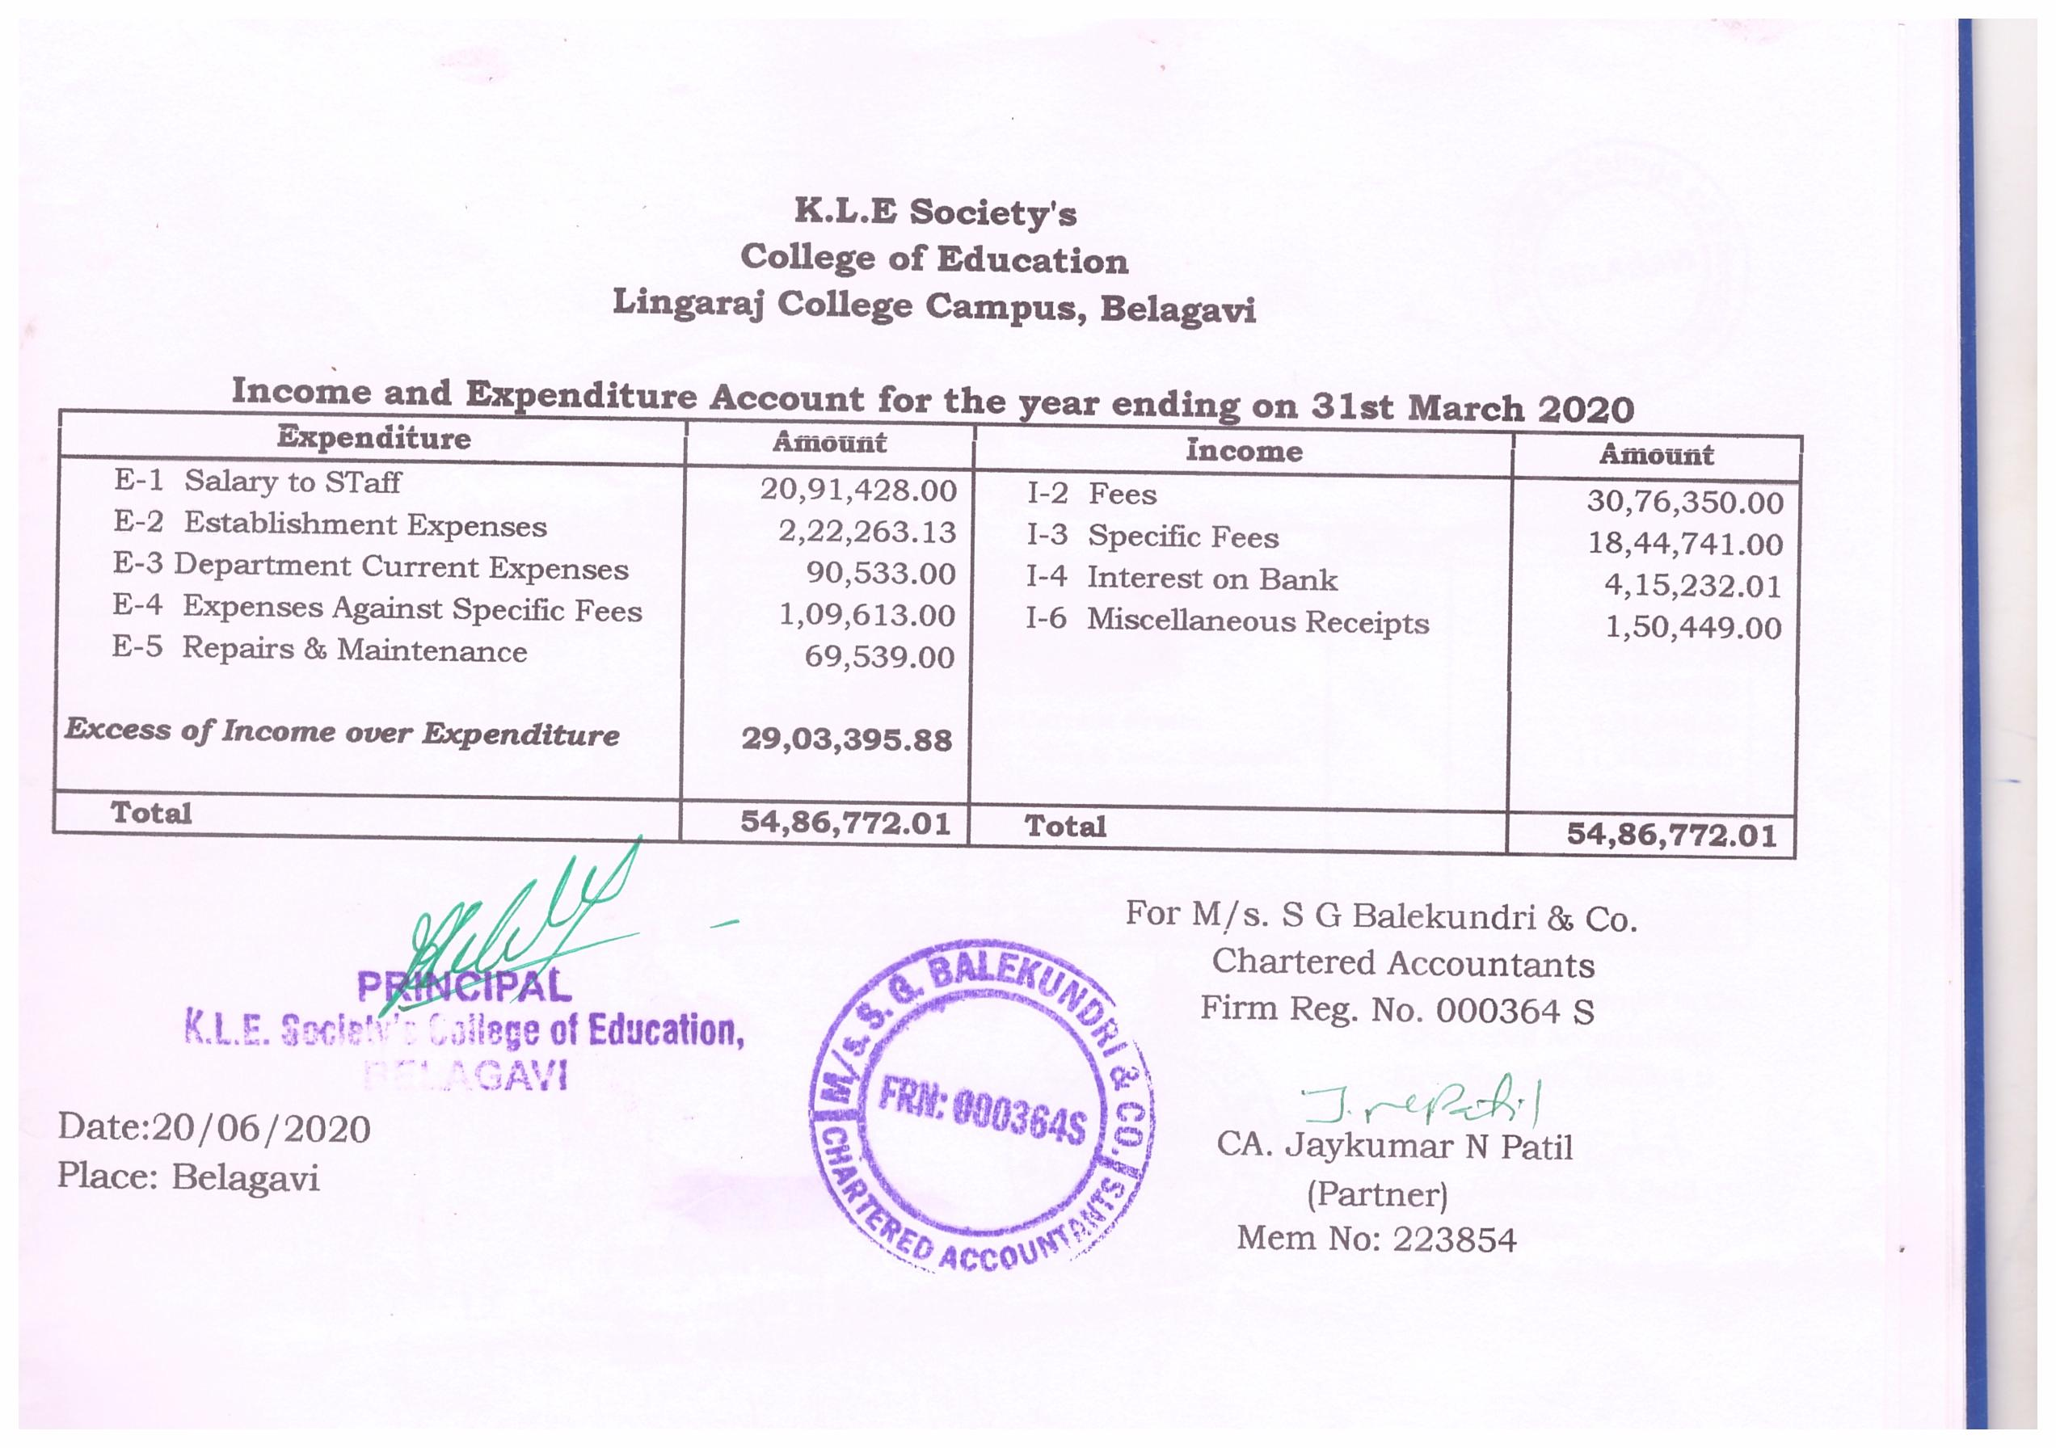

**5. Instructional Resources**

**A. Library**

|  |
| --- |
| 50 |

a) Sitting capacity in the Reading Room

|  |
| --- |
| 5220 |

b) Number of Books

|  |
| --- |
| 1335 |

c) Number of Titles

d)Number of Reference books like encyclopedias, dictionaries,

|  |
| --- |
| 68 |

Documents, reports etc.

e) Name of journals subscribed

i) Journal of Educational Psychology

ii) Journal of English Language Teaching

iii) Journal of Educational Technology

iv) University News 01

v) Education World

vi) Readers Digest

|  |
| --- |
| 88 |

f) Number of books added during the previous academic session

|  |
| --- |
| 20 |

g) Number of books added during the current academic session

**B. ICT Resource Centre**

|  |
| --- |
| 16 |

* Number of Computer systems
* Availability of Internet facility Yes
* Accessibility of Internet facility to students Yes

|  |
| --- |
| 23 |

* Number of CD ROMs
* Number of Resources added during the Current Session

Name of Resource

|  |
| --- |
| 01 |

1. Web Camera

|  |
| --- |
| 01 |

1. Wi Fi Connection

|  |
| --- |
| 02 |

1. Samsung all in Print, Scan, Copy & Fax

* Number of Resources added during the previous academic session

--Nil--

**C. Art &Craft Resource Centre (Essential items available be mentioned)**

--Nil--

* Number of Resources added during the previous academic session

---Nil--

**D. Curriculum Laboratory (Essential items available be mentioned)**

|  |  |  |
| --- | --- | --- |
| S. No. | Resources for Curriculum Laboratory | ‘’A’’ for Available and ‘’NA’’ for not available |
| i. | Resources for English Language | A |
| ii. | Resources for Science Education | A |
| iii. | Resources for Social Science Education | A |
| iv. | Resources for Regional Language Education | A |
| v. | Resources for Core Mathematics | A |
| vi. | Overhead Projector/Notice Board/Black Boards | A |

* Number of Resources added during the previous academic session

----Nil---

**E. Physical Education Resource Centre**

i. Indoor Games Materials : Carram set, Chess Board, Snake &Ladder, T.T.

ii. Outdoor Games Materials: Cricket Set, Volley Ball Set, Throw ball, Rings,

Tennis bat .

* Number of Resources added during the previous academic session

----Nil----

**6. Academic Management**

In this section, the TEIs are required to provide the following information:

* Daily working hours **8 Hours**
* Number of working days in a week. **6 Days**
* Total No. of working days in the previous academic session. **207 Days**
* Programme-wise Results of students for last three years

|  |  |  |  |  |
| --- | --- | --- | --- | --- |
| **Pass percentage in the final examination during the last three academic sessions** | | | | |
| **S.No** | **Programme** | **Session 2015-17** | **Session 2016-18** | **Session 2017-19** |
| 1 | B.Ed. | 98.85% | 97% | 98% |

* Number of Ex-students of the Institution who qualified in the Central or State Eligibility Test during the previous two years.

|  |  |  |
| --- | --- | --- |
| **Year** | **Number of Students Appeared** | **Number of Students Qualified** |
| 2019-20 | TET-40 CTET-15 | TET-22 CTET-05 |

* Mention the value added courses is offered by the TEI on own its initiative. --------------
* Name and Number of schools available for internship during the current session.

1. Govt./Govt.aided Schools
2. Govt. Kannada Higher Primary School Kanabargi.
3. Govt. Kannada High School Kanabargi.
4. Govt. Marathi Higher Primary School Belagavi.
5. K.L.E Societys .G.A. High School Belagavi.
6. K.L.E Societys .B.S.Hanchinal Higher Primary School Belagavi.
7. Shri Kalmeshwar High School M K Hubballi Tq.Kittur, Belagavi
8. Govt.Higher Primary School No.19 Majagaon, Belagavi
9. Govt.Higher Primary School No.14 Vadagaon, Belagavi
10. Govt.Higher Primary School No.03 Khasabhag, Belagavi
11. Govt.Higher Primary School No.03 Khasabhag, Belagavi
12. Govt.Higher Primary School Kakati, Tq. Belagavi
13. Govt.Higher Primary School Machhe, Tq. Belagavi
14. Govt.Higher Primary School Hudli, Tq. Belagavi
15. Govt.Higher Primary School No.7 Belagavi
16. Ganebail Haigh School Ganebail Tq.Khanapur, Belagavi
17. Manturga High School Manturga Tq.Khanapur, Belagavi
18. Malprabha High School Chapagaon,Tq.Khanapur, Belagavi
19. Sarvodaya Eng. Medium School Tq.Khanapur,Belagavi
20. Private Recognised Unaided School
21. St.Johns English Medium HIghschool Belagavi.
22. St.Peters English Medium School Belagavi
23. Maratha Mandal Eng.Medium School Belagavi
24. Gopal Jinagonda Eng.Medium School Sindolli, Belagavi
25. R.E.M.School Hirebagaewadi, Tq.Belagavi
26. Gajananrao Bhatakhande Eng.Medium School Belagavi
27. Shantiniketan Public School Khanapur Belagavi

* Total number of Pre internship days in the previous academic session **15 Days +15 Days.**
* Total Number of mentor teachers associated with the Internship

Programme 8 **Teachers**

* Did the Institution conduct orientation programme for the students before the commencement of Internship **Yes**
* Did the Institution conduct the Planning cum consultation meeting with the Heads of Internship Schools? **Yes**
* Details of Pre-Internship Schools.

a)Govt./Govt.aided Schools

1)Govt. Kannada Higher Primary School Kanabargi.

2)Govt. Kannada High School Kanabargi.

3)Govt. Sardar High School Belagavi.

4) Govt. Marathi Higher Primary School Belagavi.

5) K.L.E Societys .G.A. High School Belagavi.

6)K.L.E Societys .B.S.Hanchinal Higher Primary School Belagavi.

7) Karmaveer High School Peeranawadi

b)Private Recognised Unaided School

1)St.Johns English Medium HIghschool Belagavi.

2) Gajananrao Bhatakhande Eng.Medium School Belagavi